

SANJAY GHODAWAT UNIVERSITY

# Kolhapur

Established under section 2(f) of UGC Act 1956

Sanjay Ghodawat University Act XL of 2017 of Govt. Maharashtra Approved by PCI, COA & AICTE

**PROJECT SYNOPSIS**

**On**

**“THEATER MANAGEMENT”**

A synopsis submitted in partial fulfillment of the requirements for the

School of Computer Science and Engineering By

**Pradnya.A.Magennavar 22SC114281081**

**Vaishnavi.C.Patil 22SC114281086**

Program: Bachelor of Computer Science and Engineering Class: SY BTech

Under Supervision of

## Mrs. Priyanka Koshti

Assistant Professor

School of Computer Science and Engineering

S.Y 2023-24



SANJAY GHODAWAT UNIVERSITY

# Kolhapur

Established under section 2(f) of UGC Act 1956

Sanjay Ghodawat University Act XL of 2017 of Govt. Maharashtra Approved by PCI, COA & AICTE

**School of Computer Science and Engineering**

**CERTIFICATE**

**PROJECT SYNOPSIS**

**On**

**“THEATER MANAGEMENT”**

Submitted By

**Pradnya.A.Magennavar 22SC114281081**

**Vaishnavi.C.Patil 22SC114281086**

Program: Master of Computer Science and Engineering Class: SY BTech

Is work done by him/her and submitted during academic year 2022-23,

in partial fulfillment of the Project Synopsis.

**Sanjay Ghodawat University, Kolhapur**

**Mrs. Priyanka Koshti Dr. B. Suresh Kumar**

**Course coordinator HOS, SoCSE**

# INTRODUCTION

Have you ever been excited to watch a movie or a play but got a little lost in the process of getting your tickets? That's where our Theater Management Project comes in! Imagine it as your helpful guide to everything theater-related. We've made it super simple for you to book tickets to your favorite shows. No more waiting in long lines! You can pick your seats, choose the time that works for you, and voilà – your tickets are ready. But wait, there's more! Our project also gives you all the cool details about the movies or plays. You'll know what the show is about, who's in it, and even watch trailers to get a sneak peek. It's like having your own personal movie guide.

So, whether you're a fan of action-packed movies or love a good comedy, our Theater Management Project is here to make sure you have a fantastic time – from booking your tickets to enjoying the show. Let's get ready for some big-screen excitement!

# OBJECTIVES

# Show Information: Provide detailed information about each show.

# Real-time Availability: Display real-time availability of seats for each show, allowing patrons to choose from the available options instantly.

# Security and Data Privacy: Implement robust security measures to protect user data and financial transactions.

# Feedback Collection: Facilitate the collection of feedback from patrons.

# Efficient Ticket Booking: Simplify the ticket booking process for patrons.

# EXISTING SYSTEM

# Display movie, seat reservation, ticket booking for various shows and performances.

# Defining shows, show duration and genera .

# Seat layout visualization for patrons to choose seats.

# Ensuring secure handling of user data and payment information.

# Allowing patrons to provide feedback and rate shows.

# LIMITATION

# Functionality Complexity: As the project grows, managing different functionalities like ticket booking, seat selection, show scheduling, customer data, and payment processing can become complex and hard to maintain.

# Scalability: Handling a large number of shows, seats, and customers might strain the system's performance and lead to slow response times.

# User Interface: Designing a user-friendly interface for ticket booking and management within a console-based C++ application might not provide the best user experience.

# Accessibility: Creating an accessible application for users with disabilities, such as visual impairments, can be challenging without the capabilities of modern accessibility technologies.

# PROPOSED SYSTEM

# Implement a reservation system to prevent double booking.

# Define pricing tiers for different types of seats.

# Allow users to navigate shows, select seats, and make reservations seamlessly.

# Implement security measures to prevent unauthorized access to the system.

# Develop a payment system using C++ classes and methods.

# TECHNOLOGY USED

## SOFTWARE REQUIREMENTS

* + Dev C++ /Code::Blocks / VS code

## HARDWARE REQUIREMENTS

* + 4 GB RAM
  + 500 GB HDD
  + I5 processor

# METHODOLOGY

**Algorithm:**

* **Step 1:** Start.
* **Step 2:** It displays the main menu and user has to choose one option out of four.
* **Step 3:** If user selects first option then movie name is displayed.
* **Step 4:** If user selects second option it shows seat availability.
* **Step 5:** If user selects third option then user has to select the index along with rows and coloums.
* **Step 6:** If there is valid choice the ticket will be booked successfully.
* **Step 7:** Exit

**Flowchart**

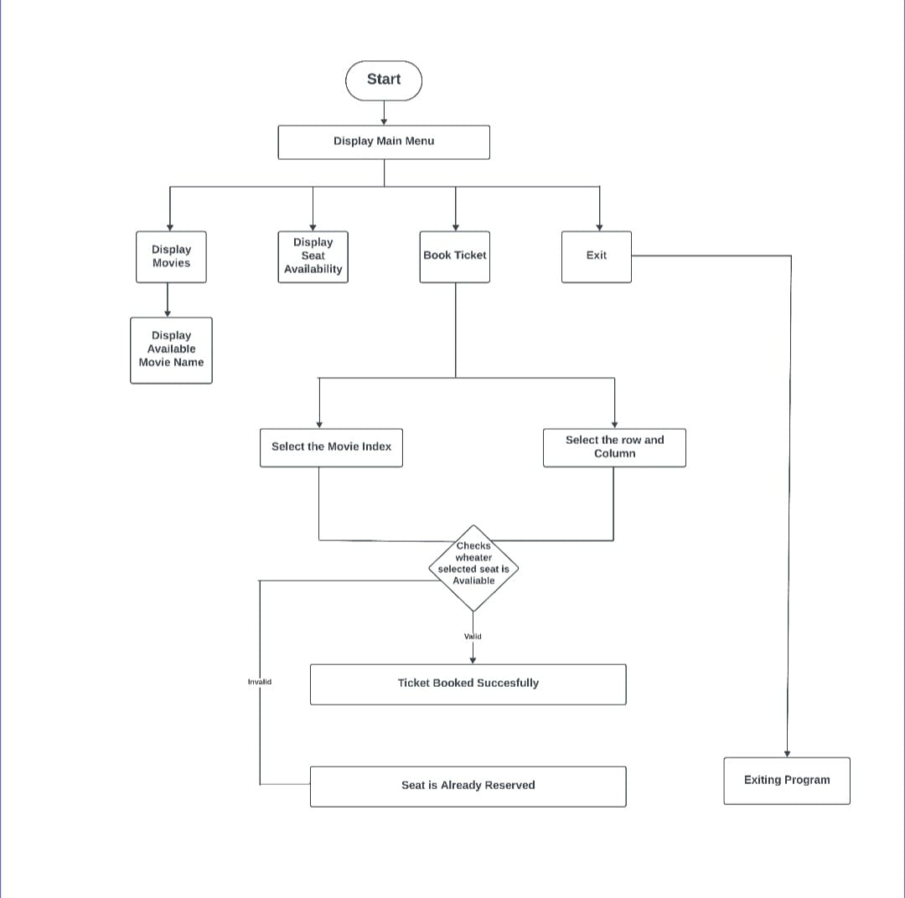

**EXPECTED OUTCOMES**

* Here we have implemented the project which gives the outcomes like it displays the movie name.
* The project also displays how many seats are available.
* It displays the booking of ticket.
* Lastly it has the exit option**.**

# REFERENCES

* Object oriented programming with E Balagurusamy.
* <https://www.slideshare.net/rajeshgangireddy/rajesh-c-report-final>
* <https://www.studocu.com/row/document/north-south-university/software>